**Sales Performances Dashboard**

**📊 Sales Performance Dashboard**

**👤 Name: K. Sunitha**

**📁 Project: Sales Performance Analysis**

**📌 Data Source**

* **Source: Kaggle**
* **Dataset: Sales Performance Dataset**
* **Fields Used:**
  + **Order ID**
  + **Order Date**
  + **Customer Name**
  + **State**
  + **City**
  + **Category**
  + **Sub-Category**
  + **Quantity**
  + **Amount**
  + **Profit**
  + **Payment Mode**
  + **Year and Month (derived)**

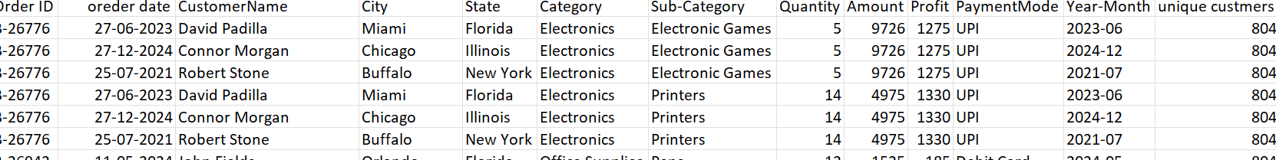

* **DATA CLEANING:**
* I check all the data it is cleaned there is no duplicate orders, blank Customer Name, ………etc.
* I set all the data in order wise like id, order date, state, city, category, sub-category, amount, quantity, profit, payment mode etc.
* I create a new column name as sale. I used formula sales =Quantity/Profit .

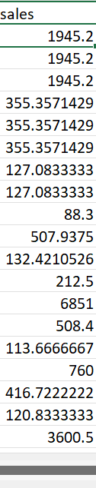

* **USING POWER-BI:**
* After that all the data load into power bi.
* Create a new column name as year I used formula “Year = YEAR('sales performance data'[Order Date])”.
* Created another new column name as month formula is “Month = MONTH('sales performance data'[order date])”

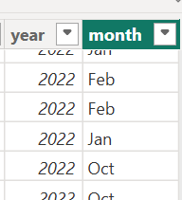

* next I find a unique customers ?



* how to increase the sales year wise?

I use forecasting tool

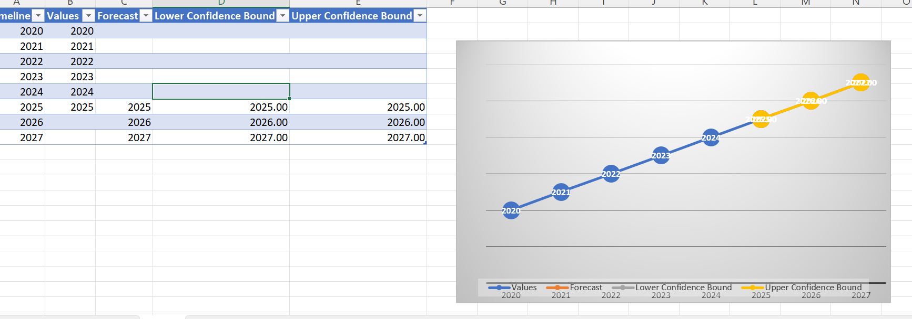

**🎯Objectives:**

* Understand sales performance across different regions (City/State).
* Analyze product category/sub-category performance.
* Identify top-performing customers.
* Discover time trends (monthly/yearly) in sales and profit.
* payment mode-wise sales contribution.

📐 **Measures (DAX Formulas Used)**

I used new measure tools

1.To find average profit ?

Average Profit = AVERAGE ('sales performance data'[Profit])



2.To find average quantity per order?

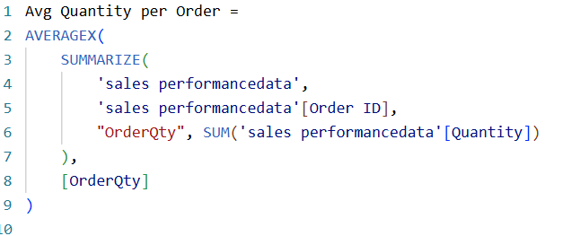

3.To find maximum profit?



4.To find minimum profit?



5.To find order count ?



6.To find payment count?



7.To find total catgeroy sale ?



8.To find total profit ?



9.To find total quantity ?



10.To find total sales ?



11.To find Previous Year Sales using dax formula ?

Previous Year Sales = CALCULATE (

    [CURRENT YEAR SALE], SAMEPERIODLASTYEAR ('sales performance data'[Oreder date].[Date]))

12.To find current year sales?

CURRENT YEAR SALE = SUM('sales performancedata'[sales])

13. to find yoy growth?

yoy growth = [CURRENT YEAR SALE]-[Previous Year Sales]

**📊 Visualizations Used:**

* Next I stared to give visuvals

1.I Used Map chart to shows sum of sales by city.

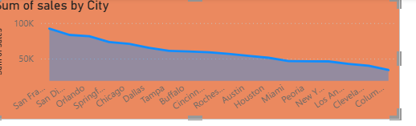

2. Used Map chart to show sum of sale by state .

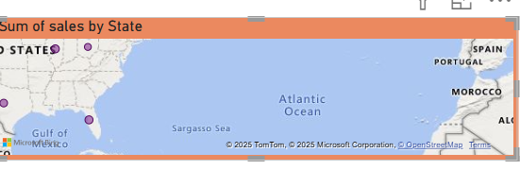

3. Used area Map chart to show average quntatity per order by year and month

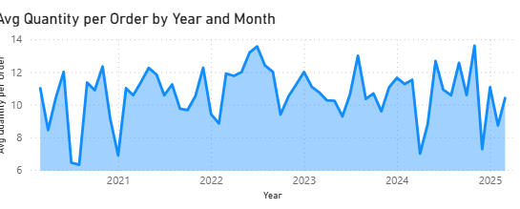

4. Used bar chart to show sum of sales by sub-categorey .

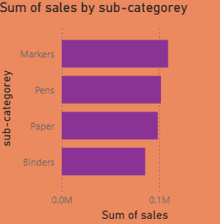

5.Used column chart to show sum of sales by categorey .

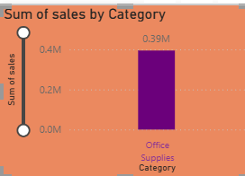

6. Used donut chart to show sum of profit by year wise .

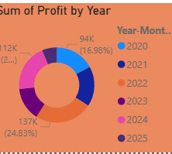

7. Used water fall chart to show sum of profit by month.

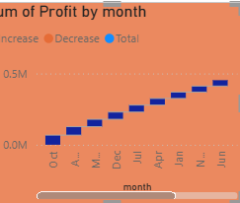  
8 . Used question and answer to show to 10 quntitys .

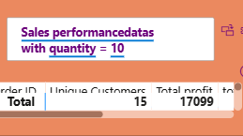

9.Used matrix table to show the paymeant mode by sum of sales.

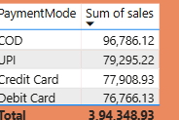

10.I Used cards to shows the totale sales, profit,categorey,quntity,sum of amount,sum of profit,order count, unick customers,average profit, average qunity ,….etc.

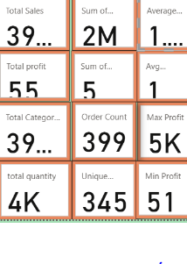 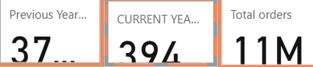

11.Use slicer to show category wise profit

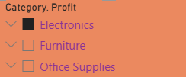

12. Using tree map to show the monthly sales by yoy growth

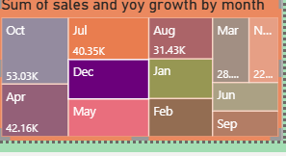

**✅ Conclusion:**

This Power BI dashboard offers clear insights into sales performance, customer behavior, and product trends. It helps identify growth opportunities and supports data-driven decisions, making it a valuable tool for improving business strategy and operations.

